|  |  |
| --- | --- |
| **WOODSIDE SCHOOL** | |
| **Anti-bullying strategy for all Woodside School** | |
| **Independent School Standards: paragraphs 10 and 34.** | |
| Policy content includes:   * what we do to prevent and respond to bullying * the role of families * how we manage allegations from pupils against other pupils. | |
| **Last external review** | September 2024 |
| **Next external review** | September 2025 |
| **Latest update** | **September 2024** |

**INTRODUCTION**

We aim to provide a positive, safe and caring learning environment for all pupils, staff and visitors to our school. To achieve this, we support and encourage everybody to be respectful of each other (this includes pupils, staff and visitors) and to report incidents of bullying that they either witness or experience themselves.

* We view all forms of bullying as completely unacceptable.
* Acts of bullying will be responded to in line with our behaviour policy (as well as the specific guidance below).
* Bullying is explored throughout our values-centred curriculum and in PSHE/PSHCE sessions.
* Where applicable, managing electronic bullying (e.g. cyber-bullying) must also be considered alongside our online safety policy.
* Our equality policy, with a particular focus on the protected characteristics (as identified in the Equality Act 2010), is also an important consideration in managing and analysing incidents of bullying.

This policy should also be read in conjunction with our ‘keeping our pupils safe’, ‘behaviour’ and ‘online safety’ policies.

**IT IS EVERYONE’S RESPONSIBILITY TO AIM TO PREVENT OCCURRENCES OF BULLYING AND TO DEAL WITH INCIDENTS QUICKLY AND EFFECTIVELY.**

**WHAT IS BULLYING?**

Bullying can take many forms. We take the view that any deliberately hurtful behaviour or action constitutes bullying. It can be an unresolved single frightening incident which can cast a shadow over a child’s life or a series of incidents. The following list is not exhaustive:

**Physical**

Violent, aggressive and/or threatening behaviour (fighting, hitting, shoving, tripping up, spitting, kicking, slapping etc.), invading personal space, sexual assault or harassment.

**Verbal**

Name-calling (including racist, sexist, homophobic, biphobic or transphobic name- calling and insults about disabilities or religion), insulting family members and others or making offensive remarks; shouting; causing embarrassment by insulting, humiliating or disciplining in public.

**Indirect (including all forms of electronic and ‘cyber’ bullying)**

Spreading malicious, nasty rumours about a person, excluding someone from a group, cyber-bullying (e.g. sending malicious or threatening emails or messages via social network sites), text messages or voice messages by mobile phone or writing and passing notes that are meant to ridicule and/or intimidate the recipient.

**WHAT DO WE DO TO PREVENT & REDUCE BULLYING?**

Whole-school initiatives and proactive teaching strategies are used throughout the schools to develop a positive learning environment with the aim of reducing the opportunities for bullying to occur. These include:

* **Clear, agreed expectations** which are highly visible in the schools and referred to in lessons and assemblies as part of our approach to promoting positive behaviour
* Our **values curriculum** which focuses on relationships, respect, dealing with conflict, trust, British values and which permeates our PSHE/PSHCE programme and our assemblies:

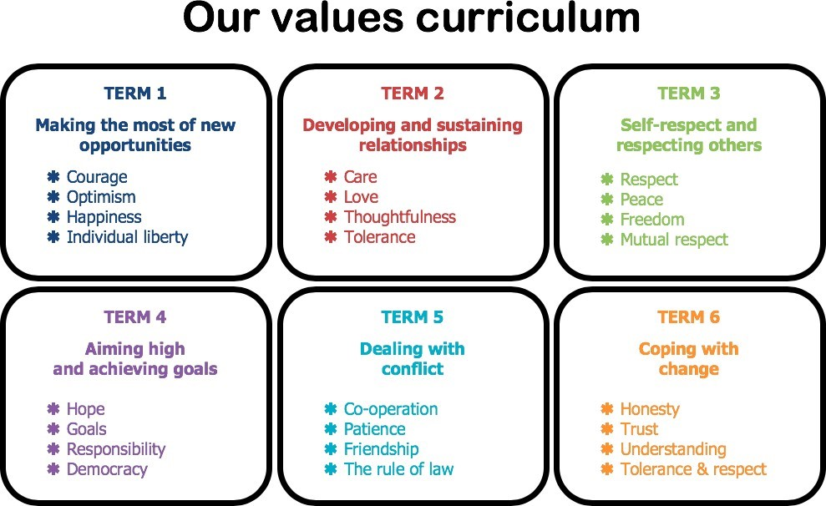

* Taking part in the national ‘anti-bullying week’ each year
* Awareness through regular, relevant assemblies
* Circle time with younger pupils
* Drama/role play activities
* An effective pupil induction process including buddies for pupils new to the schools and those who are experiencing difficulties settling in
* The following of the schools’ behaviour policy, which includes focusing on praise and rewards to reinforce good behaviour (including peer relationships, being respectful of each other etc.)
* Ongoing staff training to recognise and deal with bullying, including on specific areas such as homophobia, transphobia, biphobia, religious diversity, Islamophobia, disability discrimination and racism
* Encouraging the whole-school community to model appropriate behaviour towards one another
* Displaying Childline/NSPCC posters around the schools.

**WHAT SHOULD THE ROLE OF FAMILIES BE?**

Parents and carers have an important part to play in preventing and responding to bullying. We ask parents to look out for unusual behaviour in their child – for example not wanting to attend school, regularly feeling ill, being overly quiet, isolating themselves.

We ask that caregivers always take an active role in their child’s education, enquire how their day has gone and who they have spent time with. If a parent or carer feels their child may be a victim of bullying they must inform the schools. This information will be taken seriously and appropriate action will follow.

If as a parent or carer you feel another child has bullied your child, we ask that you **do not approach that child or their family**. Instead, **please inform us immediately**.

* **It is important that parents/carers do not advise their child to fight back or to repeat the bully’s behaviour. This will only make the situation worse.**
* **It is important to never tell a child it is their fault they are being bullied.**
* **It is hugely helpful for families to support children in asking for help.**

**HOW SHOULD BULLYING BE REPORTED AND WHAT PROCEDURES WILL WE FOLLOW WHEN RESPONDING TO BULLYING INCIDENTS?**

Allegations and incidents of bullying at Woodside Schools will be taken seriously by all staff and dealt with impartially and promptly. All of those involved will have the opportunity to be heard. Staff will support all pupils involved whilst the allegations and incidents are investigated and resolved.

The following robust, but flexible, procedures are followed:

1. **Incidents of reported bullying need to be reported to a senior leader.**

This will usually be via a teacher, therapist or family member.

1. **Depending on the incident, an appropriate member of staff will speak to all pupils involved about the incident separately or if appropriate as a group.** This will be reported to the relevant senior leader.
2. The problem will be identified and possible solutions suggested, which may include:
   * **mediation**
   * **restorative justice**
   * **circle time**
   * **drama activities which will move pupils on from having them justify their behaviour**
   * **supporting the bully/bullies to genuinely apologise**
   * **supporting the bully/bullies, through their trusted adult, to understand and change their behaviour**
   * **sanctions, including exclusion, as per our behaviour policy.**
3. **In the unlikely event the bullying continues, or in more serious cases of bullying, families will be invited into the school for a meeting to discuss the problem** and in very rare cases, mediation/restorative justice meetings with both families and pupils present may be used to resolve the issues.

All incidents of bullying are logged by category on the schools’ electronic data management system and analysed in leadership team meetings.

Actions from this analysis (e.g. staff training, timetable changes, specific support plans, etc) are then implemented as appropriate to reduce, eradicate or prevent further cases of bullying.

Our staff have a good understanding of where bullying comes from in each individual - knowing that children who have good self-esteem, empathy, a good sense of their own identity and the ability to make and maintain positive relationships are unlikely to take part in bullying behaviours.

We therefore focus on supporting pupils to develop their self-esteem, positive relational experiences and use psychoeducation to highlight the feelings underneath the behaviours, to ultimately stop recurring bullying, give the pupil personal insights and work towards meaningful change.

**THE PROTECTED CHARACTERISTICS (FROM THE EQUALITY ACT 2010)**

This policy, alongside complementary publications such as our equality policy, ensures that the schools’ curriculum and systems for managing behaviour pay regard to the protected characteristics set out in the Equality Act 2010 which include age, disability, gender reassignment, race, religion or belief, sex, sexual orientation and marriage/civil partnership/pregnancy/maternity.

**ALLEGATIONS FROM PUPILS AGAINST OTHER PUPILS**

In most instances, negative conduct of pupils towards each other will be covered by this policy (and our behaviour policy). However, some allegations may be of a more serious nature and raise safeguarding concerns. Allegations made against another pupil may include physical abuse (e.g. violence, particularly pre-planned; forcing the use of drugs or alcohol), emotional abuse (e.g. bullying, blackmail, extortion, threats, intimidation), sexual abuse (e.g. indecent exposure, touching, sexual violence and sexual harassment, sexting, forcing the watching of pornography or upskirting, which is a criminal offence and typically involves someone taking a picture under a person’s clothing without them knowing, with the intention of viewing their genitals or buttocks to obtain sexual gratification, or cause the victim humiliation, distress or alarm and/or sexual exploitation (e.g. photographing or videoing indecent acts).

Sexting is sending or posting sexually suggestive images, including nude or semi- nude photographs, via mobiles or over the internet. If any devices need to be seized and passed onto the police, then the device(s) will be confiscated, and our safer schools police officer will be contacted. The device will be turned off and placed in the safe until the police are able to come and retrieve it.

**In this case, the allegation must be logged using our online safeguarding portal and will be dealt with as a safeguarding concern by our DSL. Further guidance on this area can be found in our safeguarding policy.**